**Chapter One: Introduction and Background**

The dental clinic is one of the important parts of our life. All of people have to go to the dental clinic when they get some problem with their teeth such as toothache, gum ache or teeth braces. It also is like when we go to the hospital, but for the dental clinic it treats only problem with the tooth. In one, clinic has many patient and many cases for treating. The popular general case is the teeth braces which often require long term treatment possibly up to 4 years. The patient who has teeth braces has to make an appointment with the dentist around once a month.

The problem is the patient often loses their appointment card and forgets the appointment date, which may affect their health. They will have some trouble with their teeth, which sometimes can be very dangerous. In some case, the patient wants to change the appointment date. They do not know exactly when the dentist is free because the dentist has his own schedule which contains all of the patient appointments. Besides the problems with appointments. The patient wants to know the total price of his case

To solve these problems, “The dental clinic website and mobile application” includes functions for patients, visitors, officer and dentist. For visitors who are interested in dental treatments, in website and mobile application will provide information about teeth treating and estimate the cost. Also, visitors can interact with the dentist on the web. Visitors can consult with dentists about some problem they are experiencing. This website and mobile application includes dentists schedule and also the appointment function, visitor can make an appointment with a dentist. For the patient, the website and mobile application contains the reminder function for reminding the patient when he/she have an appointment to prevent the patient from forget an appointment, and this function will make a notice when schedule change. It will notify about the appointment in 1-2 days before the appointment date. The dental clinic website and application also can generate the QR code to patients, and they can use QR code to identify their appointment at the clinic also to prevent the patient from lost or forget the appointment card.

.

**Chapter Two: Literature Review**

**2.1 Business review**

**2.1.1 Dental Clinic Website and Mobile application**

Dental Clinic Website and Mobile application is an application that provide service to customer of Dental Clinic(patient) such as dentist's schedule, managing appointment and reminder, promotion, dental's information, follow up and consulting between dentist and patient. Customer can access both web application and mobile application that Officer insert into the website. Dentist can have an interaction with customer through both application too, by follow up and giving out the consulted to the patient.

Examples of dental website and mobile application are shown below

**2.1.1.1 Dental Clinic by Cosmetic Innovations, Inc**.

Dental Clinic is a patient’s guide to understanding all aspects of dentistry and its procedures. This application includes the most frequently asked dental questions answered by the top dental experts in each field, and overseen by NYC Cosmetic & General Dentist - Dr. Marc Lazare. This app includes:

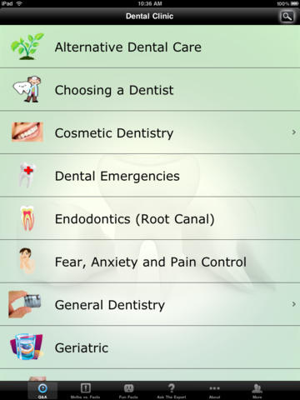

Figure 1: Show all menu that customer can use.

As shown in Figure 1, when user open the application user can see all of these menu that user can select to see informations

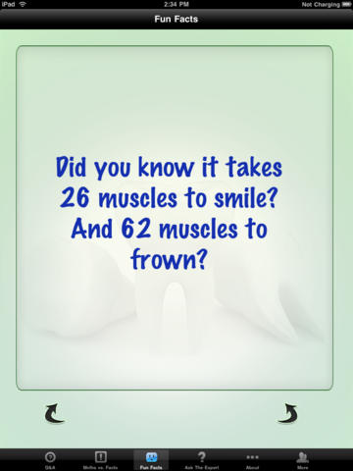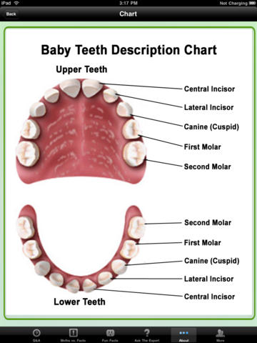

Figure 2: Show user interface after user select some menu

As shown in Figure 2, user can select to see the useful information such as Best ways to minimize your pain, fear and anxiety • All of the important information you should know about your children’s dental care • Knowing what all of your options are when missing one or more teeth • What you should know about teeth whitening.

### 2.1.1.2 Dr.Sunil Dental Clini - Cosmetic, Oral & Implant Dentistry

The website for Dental Center in Bangkok which provide for foreign customer to advertising the clinic with full functional services provide to customer. Their customer can fill the document form to get an appointment. Customer also can use provided QR code to call, email, and visit the site of dental clinic. But this website is only for customer side and has only some information of dental care, dentist cannot interact with customer directly.

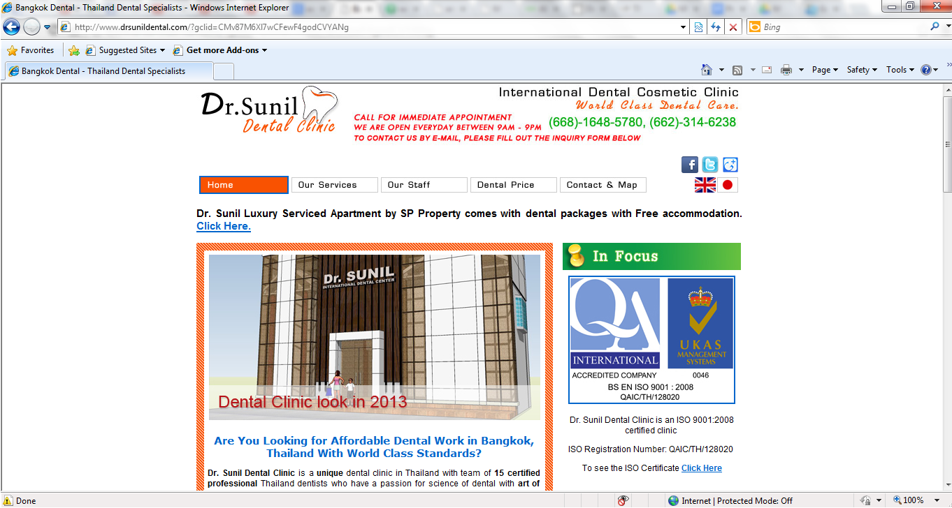

### 

Figure 3: Show website of Dr.Sunil Dental Center

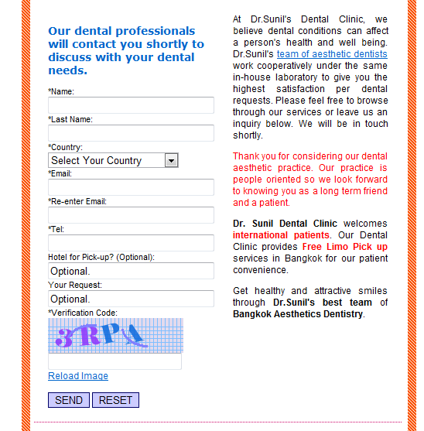

Figure 4: Show the contact with Dr. Sunil

As shown in Figure 4, Customer can send their information to Dr. Sunil and wait for email and might get the appointment.

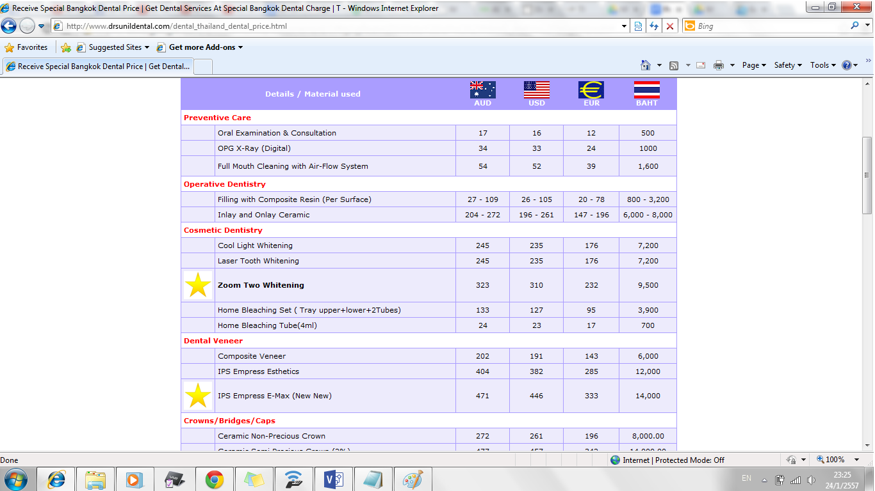

Figure 5: Show the price rate

As shown in Figure 4, Customer can see the cos that they have to pay for each treatment.

**2.2 Technology Review**

**2.2.1 QR code**

**2.2.1.1 QR code**

A QR code (quick response code) is a type of [2D bar code](http://searchmobilecomputing.techtarget.com/definition/2D-barcode) that is used to provide easy access to information through a [smartphone](http://searchmobilecomputing.techtarget.com/definition/smartphone).

In this process, known as mobile tagging, the smartphone’s owner points the phone at a QR code and opens a [barcode reader](http://whatis.techtarget.com/definition/barcode-reader-POS-scanner-bar-code-reader-price-scanner) app which works in conjunction with the phone’s camera. The reader interprets the code, which typically contains a call to action such as an invitation to download a mobile application, a link to view a video or an [SMS](http://searchmobilecomputing.techtarget.com/definition/Short-Message-Service) message inviting the viewer to respond to a poll. The phone’s owner can choose to act upon the call to action or click cancel and ignore the invitation. The QR code can recognize the URL website normally the URL website is difficult to keep because it’s too long and some of it is too complex. For QR code just use the scan the item which have the QR code it’s will link to the website of that item.[1] **API QR Codes**

An application programming interface (API) which allows you to send requests to create qr codes and returns a png image version of the QR code.Requests are made using simple HTML requests and if successful will return raw image data. [jquery.qrcode.js](http://jeromeetienne.github.com/jquery-qrcode) is *jquery plugin for a pure browser qrcode generation*. It allows you to easily add qrcode to your webpages. It’s enables you to dynamically add QR codes to your website. [2]

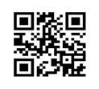

**2.2.1.2 Alternative Technology**

The QR code is quite similar with barcode and RFID all of them are contain the information. This kind of technology can be replaces the QR code. The barcode is normally uses more than QR code and RFID especially it cheaper than the others. Finally they can store information in the platform like a symbol and reliable.

**2.2.1.3 The selection of this technology**

For choosing QR code technology because this kind of tool is now very popular and most of people use a smart phone it’s easy to use and comfortable. The QR code can solve the problem by the patient don’t need to bring the appoint card when come to the clinic. And another reason is it’s faster and reliable than the appointment card. The patient can use the QR code only in the smart phone that has a program support the QR code application. We use the javascript qr code because it is the web application so, the javascript QR code as a plug in for the web browser.

**2.2.2 Phone GAP**

**2.2.2.1 Phone GAP**

[PhoneGap](http://www.phonegap.com) is an application framework that enables you to build natively installed applications using HTML and JavaScript. The easiest way to think of PhoneGap is a web view container that is 100% width and 100% height, with a JavaScript programming interface that allows you to access underlying operating system features. You build your user interface using traditional web development skills (HTML, CSS, & JavaScript), and use the PhoneGap container to deploy to different application ecosystems and devices. When packaged for deployment, the PhoneGap application is a binary distributable file that can be distributed by the “normal” application marketplaces (iTunes, Google App Market, Amazon Market, etc…)

PhoneGap can be used to build applications that target multiple platforms, including Apple iOS, Google Android, Windows Phone, BlackBerry, HP WebOS, Symbian, and Bada.[3]

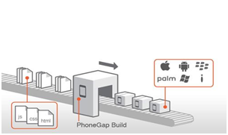

**2.2.2.2 Alternative Technology**

Xcode and Titanium mobile app development these are tool to create the mobile application which can use on smartphone and tablet. The Xcode is native program to develop the ios mobile app directly. But Titanium can create in many plstform it is similar to phonegap. It can create ios,android,and etc. The programming languages that always use to develop are javascript,HTML,css,Phythom,Ruby,PHP.

**2.2.2.3 The selection of this technology**

For choosing phonegap to develop the application because this kind of technology is flexible, convenient and it is an open source. We will create the mobile application by use html5,css,javascript all of these are supported in phonegap. And it can support 7 kinds of operating system there the one of os that we need to use is ios. Phonegap will wrap the website to be the application it contains the feature that we have to use such as camera function or database.

**2.2.3 HTML5**

**2.2.3.1 HTML5**

## HTML 5 is markup language for using to create the website. It develops form the HTML has more feature such as working with MAP system, create a graphic without flash. And the HTML5 is support for use in many operating systems there are PC, MAC, iPhone, iPad, Android or tablet. It focus to working with CSS and java script. HTML5 not only to develop the world wide web also but it can create the mobile application.



**2.2.3.2 Alternative Technology**

-

**2.2.3.3 The selection of this technology**

For choosing the HTML5 because this kind of technology is the newest version of the HTML and it can use in the phonegap program. So, for the dental clinic website and dental application clinic can use the HTML5 to create. We should to use for develop the mobile application of dental clinic. We can use HTML5 with css and javascript in phonegap.

**2.2.4 SQLite**

**2.2.4.1 SQLite**

## SQLite is an in-process library that implements a [self-contained](http://www.sqlite.org/selfcontained.html), [serverless](http://www.sqlite.org/serverless.html), [zero-configuration](http://www.sqlite.org/zeroconf.html), [transactional](http://www.sqlite.org/transactional.html) SQL database engine. The code for SQLite is in the [public domain](http://www.sqlite.org/copyright.html) and is thus free for use for any purpose, commercial or private. SQLite is currently found in more applications than we can count, including several [high-profile projects.[4]](http://www.sqlite.org/famous.html)



**2.2.4.2 Alternative Technology**

MySQL is a database is a structured collection of data. It may be anything from a simple shopping list to a picture gallery or the vast amounts of information in a corporate network. To add, access, and process data stored in a computer database, you need a database management system such as MySQL Server. Since computers are very good at handling large amounts of data, database management systems play a central role in computing,as standalone utilities, or as parts of other applications.[5]



**2.2.4.3 The selection of this technology**

For choosing this kind of technology because the information of patient and information of the treatment and the others. All of these have to store in the database. It is the stable information and must not lost because it is a secret information. The system should make it private.

**Chapter Three : Quality Standard**

**3.1 ISO29110 for Very Small Entity(VSE)**

ISO29110 is a guide applies to a Very Small Entity (SVE), enterprise, organisation, department or project up to 25 people, dedicate to software development. The Guide provides Project Management and Software Implementation process which integrate practices based on the selection of ISO/IEC 12207- System and Software Engineering - Software Life Cycle Processes and ISO/IEC 15289 Software Engineering - Software Life Cycle Process - guidelines for the content of software life cycle process information products(documentation) standard elements.

**3.1.1 Project Management Process**

The propose of the Project Management process is to establish and carry out in a systematic way the task of the software implementation project, which allows complying with the project’s objectives in the expected quality, time and cost.

**Selected process**

3.1.1.1 Project Planing Process

3.1.1.2 Project Plan Excution Process

3.1.1.3 Project Plan Assesment and Control Process

3.1.1.4 Project Closer Process

**3.1.2 Software Implementation process**

The purpose of the Software Implementation process is the systematic performance of the analysis, design, construction, integration and tests activities for new or modified software products according to the specified requirements.

**Selected process**

3.1.2.1 Software Implementation Initiation Process

3.1.2.2 Software Requirements Analysis Process

3.1.2.3 Software Architectural Design Process

3.1.2.4 Software Construction Process

3.1.2.5 Software Integration and Test Process

3.1.2.6 Software Delivery Process

**Chapter Four : Project Plan**

**4.1 Motivation**

In Thailand, nowadays people are more interesting in dental care, and the dental clinic increase very fast, and each clinic has a different amount of patient. Dental clinic needs to handle many patients also many problem. From this problem is their patient forget their appointment, patient did not have any knowledge about dental care, patient don’t know the dentist schedule. For the dental website and mobile application will help dental clinic to solve these problems.

Attributed to the recent years, from the research found that the smartphone user in 2013 are increased by 29.1 percent from 2012 and found that people using mobile internet increased by 32 percent in 2013. People always use their phone to do many thing such as entertaining, booking, shopping, communicating, accounting, and marketing. IOS is one of popular operating system, for dental clinic using IOS is more suitable because apple company need to approve the application first, so it’s guarantee that the application is approved by high quality company. For the user who not use IOS or smartphone another way that the user can keep contact is using the internet through browser.

When patient arrive at the dental clinic they have to provide their appointment card to an officer and it take times. To use QR code to identify the appointment and reduce the work of officer. For the dental clinic, QR code is more suitable than barcode because QR code can be read from smartphone also paper and card.

**4.2 Aim and Objective**

The aim of the dental clinic website and mobile application is to developing a website and mobile application that can help the patient to get make and appointment to the dental clinic and dentist, manage the appointment schedule both dentist and patient, remind the patient about an upcoming appointment, to provide the dentist’s schedule for the visitor who wants to make an appointment, reduce the time and work of the dental clinic officer and to make sure that the patient has an appointment, have a place for patient getting consult form dentist, also giving out any knowledge about dental treatment and dental care.

Objectives

1. To develop the web application and mobile application which

1.1 Facilitate patient to make an appointment.

1.2 Facilitate patient to receive an appointment.

1.3 Facilitate patient to receive the reminder of the appointment date.

1.4 Facilitate patient to find the free time for making an appointment.

1.5 Facilitate patient to change the time to meet the dentist

1.6 Facilitate patient to ask for an advice with the dentist when he/has has a problem.

1.7 Facilitate visitor to estimate cost of the treatment program.

1.8 Facilitate patient who has a smart phone to use the QR code instead of the appointment card.

1.9 Facilitate patient and visitor to see the information and advertisement about the dental clinic

2. To provide the service which supports the mobile application and web application on 1

**4.3 Architecture**

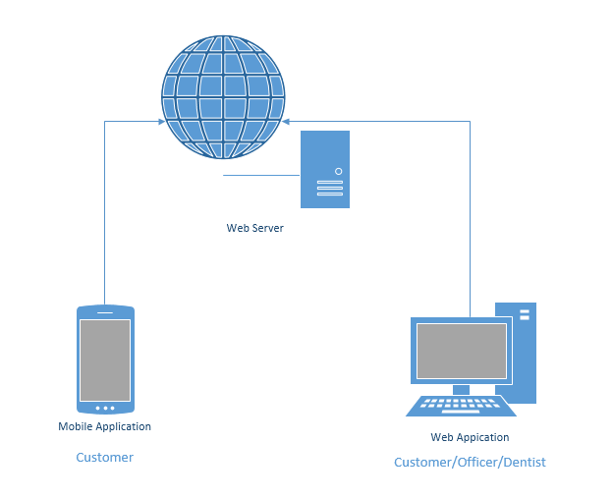

**4.4 Deliverables and Limits**

**4.4.1 Deliverables**

The dental clinic application, the final product will consist of

**Software system**

**1. Web application**

In dental web application is a website to support the clinic which has many patients. To solve the patient’s problem so, on the website patient and visitor can do these function which is

- Making an appointment when the patient want to change their appointment date

- Finding the dentist free time in the schedule that provide on the web to make an appointment

- Receiving the appointment from the dental clinic server

- Receiving the reminder of the appointment date

- Receiving the details of appointment as a QRcode

- Advice to the dentist if the patient or visitor has some problem

- View the information about the dental problem,treatment and advertisement

- View the dentist schedule day by day

- Estimate the cost of treatment program

**2. Mobile application**

In dental mobile application is an application on smartphone in IOS operating system to support the clinic which has many patients. To solve the patient’s problem so, on the mobile application patient and visitor can do these function which is

- Making an appointment when the patient want to change their appointment date

- Finding the dentist free time in the schedule that provide on the web to make an appointment

- Receiving the appointment from the dental clinic server

- Receiving the reminder of the appointment date

- Receiving the details of appointment as a QRcode

- Use the QRcode instead of appointment cardwhen come to the clinic

- Advice to the dentist if the patient or visitor has some problem

- View the information about the dental problem,treatment and advertisement

- View the dentist schedule day by day

- Estimate the cost of treatment program

**3. Web service**

The web service support following :

- Sending appointment information

- Generating the appointment information to become QRcode

- Authentication and authorization

- File hosting

-

**Documentation**

- Software Engineering document(SRS,test report,Design document)

**4.4.2 Limits**

- Web application can run on Internet explorer, Mozilla firefox, and google chrome

- Mobile(smart phone) which should use operating system iPhone 7.0

In order to run the application, if the device has older version it might support

- Mobile(smart phone) which use must support Edge,Wifi and 3G

- Internet access for mobile , website and web service

Without Internet Access, user can receive the message from clinic.

*(message contain the appointment information)

**4.5 Future work**

- Available on every operating system platform

- Use other technology to make a comfortable to user such as RFID,

**4.6 Schedule and Milestone**

This section is schedule and milestone that cover all several activity to be undertaken in the project. In the plan , the project will be complete by September, 2014 and a detail work plan with the details of each activity listed below will be prepared at the beginning of the project. To reach this goal, We will follow the schedule that we plan

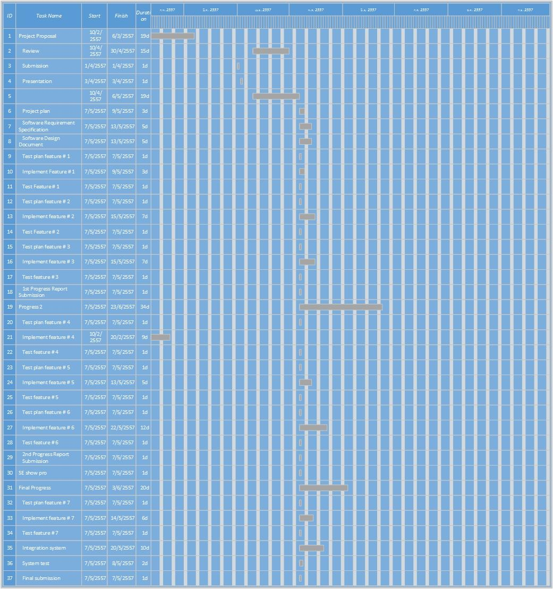**Chapter five : References**

[1] <http://searchengineland.com/what-is-a-qr-code-and-why-do-you-need-one-27588>

[2] <http://larsjung.de/qrcode/>

[3] <http://phonegap.com/about/features>

[4] http://[sqlite.org/‎](http://www.sqlite.org/famous.html)

[5] <http://dev.mysql.com/doc/refman/4.1/en/what-is-mysql.html>

[6] <http://www.atimedesign.com/webdesign/%E0%B8%A7%E0%B8%87%E0%B8%81%E0%B8%B2%E0%B8%A3%E0%B8%AA%E0%B8%A1%E0%B8%B2%E0%B8%A3%E0%B9%8C%E0%B8%97%E0%B9%82%E0%B8%9F%E0%B8%99%E0%B9%84%E0%B8%97%E0%B8%A2%E0%B8%81%E0%B8%B1%E0%B8%9A%E0%B9%80%E0%B8%A7/>

[7] <http://thumbsup.in.th/2013/04/increase-mobile-users-push-web-responsive-design/>